**PRACTICAL-2.1**

**AIM:**

**Design an application representing a simple Calculator.**

**PROGRAM CODE:**

* **XML Code:**

<?xml version="1.0" encoding="utf-8"?>

<LinearLayout xmlns:android="http://schemas.android.com/apk/res/android"

xmlns:app="http://schemas.android.com/apk/res-auto"

xmlns:tools="http://schemas.android.com/tools"

android:layout_width="match_parent"

android:layout_height="match_parent"

android:background="#CDDC39"

android:orientation="vertical"

android:padding="20dp"

tools:context=".MainActivity">

<TextView

android:layout_width="wrap_content"

android:layout_height="wrap_content"

android:layout_marginBottom="16dp"

android:text="CALCULATOR"

android:textColor="#E91E63"

android:textSize="25sp" />

<LinearLayout

android:layout_width="match_parent"

android:layout_height="wrap_content"

android:layout_marginBottom="20dp"

android:orientation="horizontal">

<EditText

android:id="@+id/first"

android:layout_width="102dp"

android:layout_height="59dp"

android:layout_marginHorizontal="50dp"

android:ems="10"

android:hint="Enter"

android:textColor="#E91E63" />

<EditText

android:id="@+id/second"

android:layout_width="102dp"

android:layout_height="59dp"

android:ems="10"

android:hint="Enter"

android:textColor="#E91E63" />

</LinearLayout>

<LinearLayout

android:layout_width="383dp"

android:layout_height="wrap_content"

android:layout_marginBottom="20dp"

android:orientation="horizontal">

<TextView

android:id="@+id/answer"

android:layout_width="315dp"

android:layout_height="59dp"

android:layout_marginHorizontal="50dp"

android:hint="answer"

android:textColor="#673AB7"

android:textSize="35sp" />

</LinearLayout>

<LinearLayout

android:layout_width="wrap_content"

android:layout_height="wrap_content"

android:layout_marginLeft="250dp"

android:layout_marginBottom="30dp"

android:orientation="vertical">

<Button

android:id="@+id/sub"

android:layout_width="wrap_content"

android:layout_height="wrap_content"

android:layout_marginBottom="16dp"

android:text="-"

android:textSize="25sp"

app:rippleColor="#FFEB3B" />

<Button

android:id="@+id/add"

android:layout_width="wrap_content"

android:layout_height="wrap_content"

android:layout_marginBottom="16dp"

android:text="+"

android:textSize="25sp"

app:rippleColor="#FFEB3B"

tools:ignore="OnClick" />

<Button

android:id="@+id/div"

android:layout_width="wrap_content"

android:layout_height="wrap_content"

android:layout_marginBottom="16dp"

android:text="/"

android:textSize="25sp"

app:rippleColor="#FFEB3B" />

<Button

android:id="@+id/mul"

android:layout_width="wrap_content"

android:layout_height="wrap_content"

android:layout_marginBottom="16dp"

android:text="X"

android:textSize="25sp"

app:rippleColor="#FFEB3B" />

<Button

android:id="@+id/equals"

android:layout_width="wrap_content"

android:layout_height="wrap_content"

android:layout_marginBottom="16dp"

android:text="="

android:textSize="35sp"

app:rippleColor="#FFEB3B" />

</LinearLayout>

<EditText

android:id="@+id/editTextNumber"

android:layout_width="match_parent"

android:layout_height="wrap_content"

android:ems="10"

android:inputType="number" />

<EditText

android:id="@+id/editTextNumber2"

android:layout_width="match_parent"

android:layout_height="wrap_content"

android:ems="10"

android:inputType="number" />

</LinearLayout>

* **Java Code:**

package com.parthnpatel.simplecalculator;

import androidx.appcompat.app.AppCompatActivity;

import android.os.Bundle;

import android.view.View;

import android.widget.Button;

import android.widget.EditText;

import android.widget.TextView;

import android.widget.Toast;

public class MainActivity extends AppCompatActivity {

EditText no1 , no2;

Button add ,mul ,div , sub,equal;

TextView answer;

double ans = 0;

@Override

protected void onCreate(Bundle savedInstanceState) {

super.onCreate(savedInstanceState);

setContentView(R.layout.activity_main);

no1 = findViewById(R.id.first);

no2 = findViewById(R.id.second);

add = findViewById(R.id.add);

mul = findViewById(R.id.mul);

div = findViewById(R.id.div);

sub = findViewById(R.id.sub);

equal = findViewById(R.id.equals);

answer = findViewById(R.id.answer);

add.setOnClickListener(new View.OnClickListener() {

@Override

public void onClick(View v) {

String num1 = no1.getText().toString();

String num2 = no2.getText().toString();

if (num1.isEmpty() || num2.isEmpty()) {

Toast.makeText(getApplicationContext(),"Enter Numbers",Toast.LENGTH_SHORT).show();

}

else {

double a = Double.parseDouble(no1.getText().toString());

double b = Double.parseDouble(no2.getText().toString());

ans = a + b;

}

}

});

sub.setOnClickListener(new View.OnClickListener() {

@Override

public void onClick(View v) {

String num1 = no1.getText().toString();

String num2 = no2.getText().toString();

if (num1.isEmpty() || num2.isEmpty()) {

Toast.makeText(getApplicationContext(),"Enter Numbers",Toast.LENGTH_SHORT).show();

}

else {

double a = Double.parseDouble(no1.getText().toString());

double b = Double.parseDouble(no2.getText().toString());

ans = a - b;

}

}

});

mul.setOnClickListener(new View.OnClickListener() {

@Override

public void onClick(View v) {

String num1 = no1.getText().toString();

String num2 = no2.getText().toString();

if (num1.isEmpty() || num2.isEmpty()) {

Toast.makeText(getApplicationContext(),"Enter Numbers",Toast.LENGTH_SHORT).show();

}

else {

double a = Double.parseDouble(no1.getText().toString());

double b = Double.parseDouble(no2.getText().toString());

ans = a * b;

}

}

});

div.setOnClickListener(new View.OnClickListener() {

@Override

public void onClick(View v) {

String num1 = no1.getText().toString();

String num2 = no2.getText().toString();

if (num1.isEmpty() || num2.isEmpty()) {

Toast.makeText(getApplicationContext(), "Enter Numbers", Toast.LENGTH_SHORT).show();

} else {

double a = Double.parseDouble(no1.getText().toString());

double b = Double.parseDouble(no2.getText().toString());

if (b != 0)

ans = a / b;

else

Toast.makeText(getApplicationContext(), "Enter Valid Numbers", Toast.LENGTH_SHORT).show();

}

}

});

equal.setOnClickListener(new View.OnClickListener() {

@Override

public void onClick(View v) {

String ans1 = String.valueOf(ans);

answer.setText(ans1);

ans= 0;

}

});

}

}

**OUTPUT:**

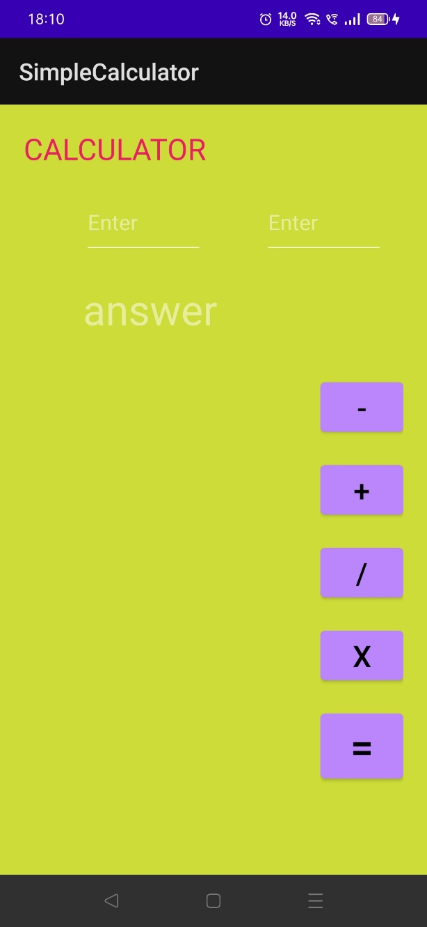

**BASIC INTERFACE**

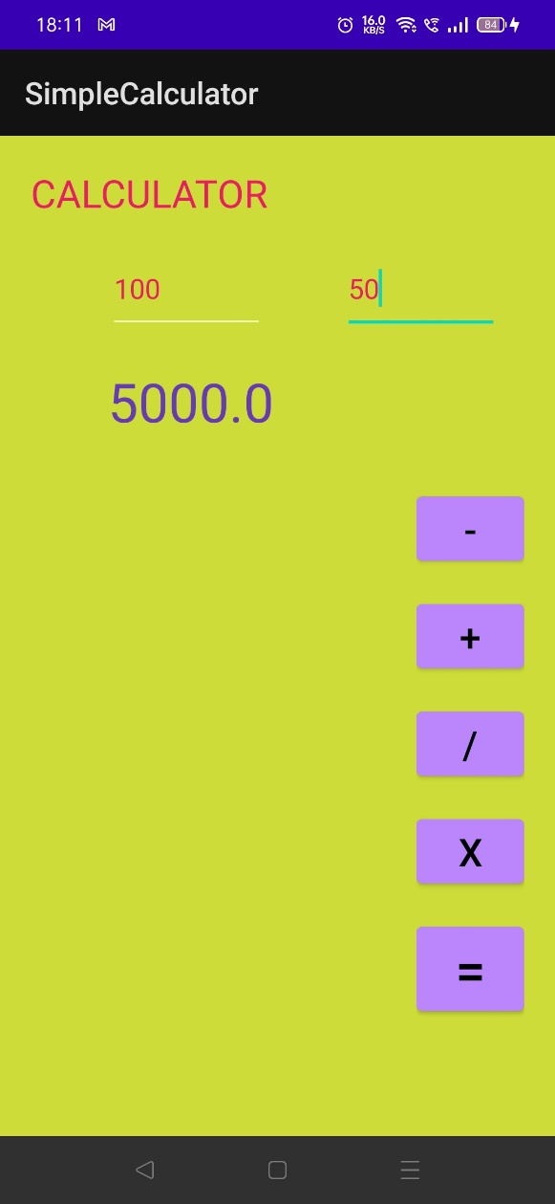

**MULTIPLICATION**

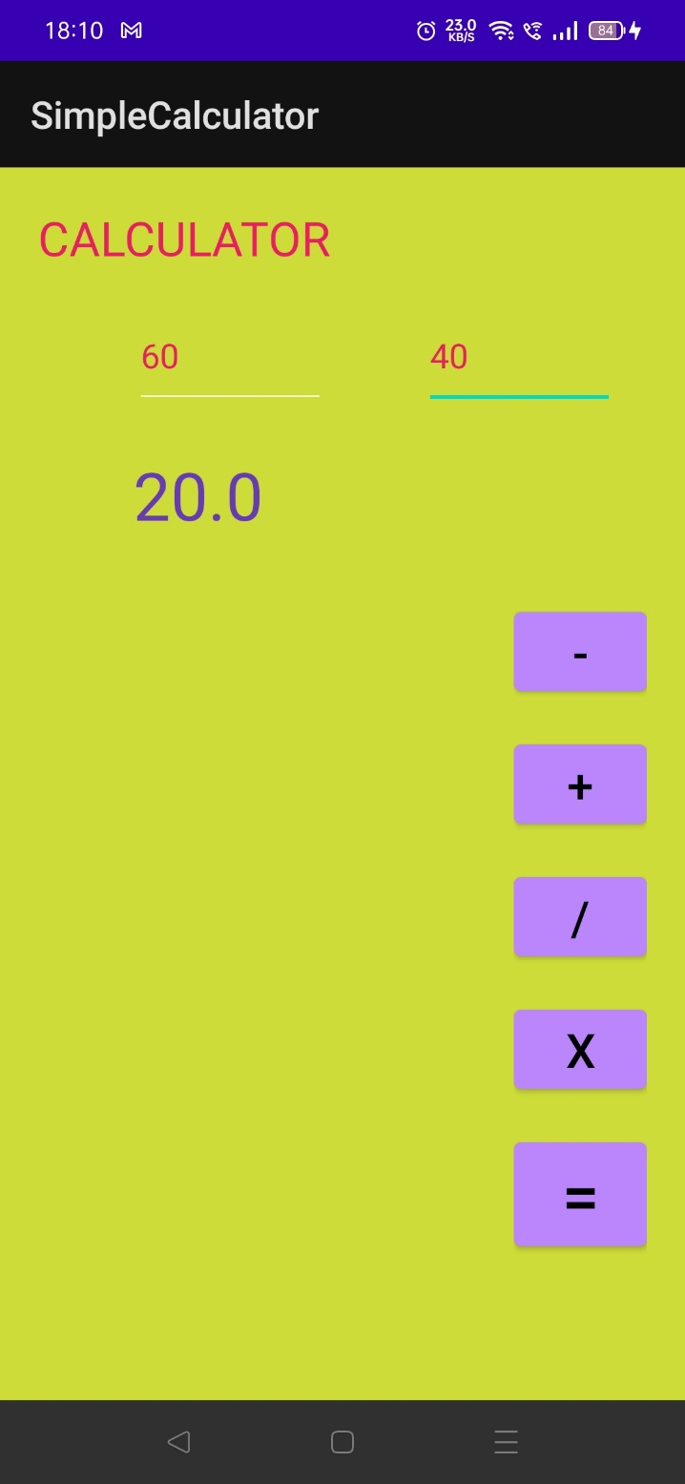

**SUBTRACTION**

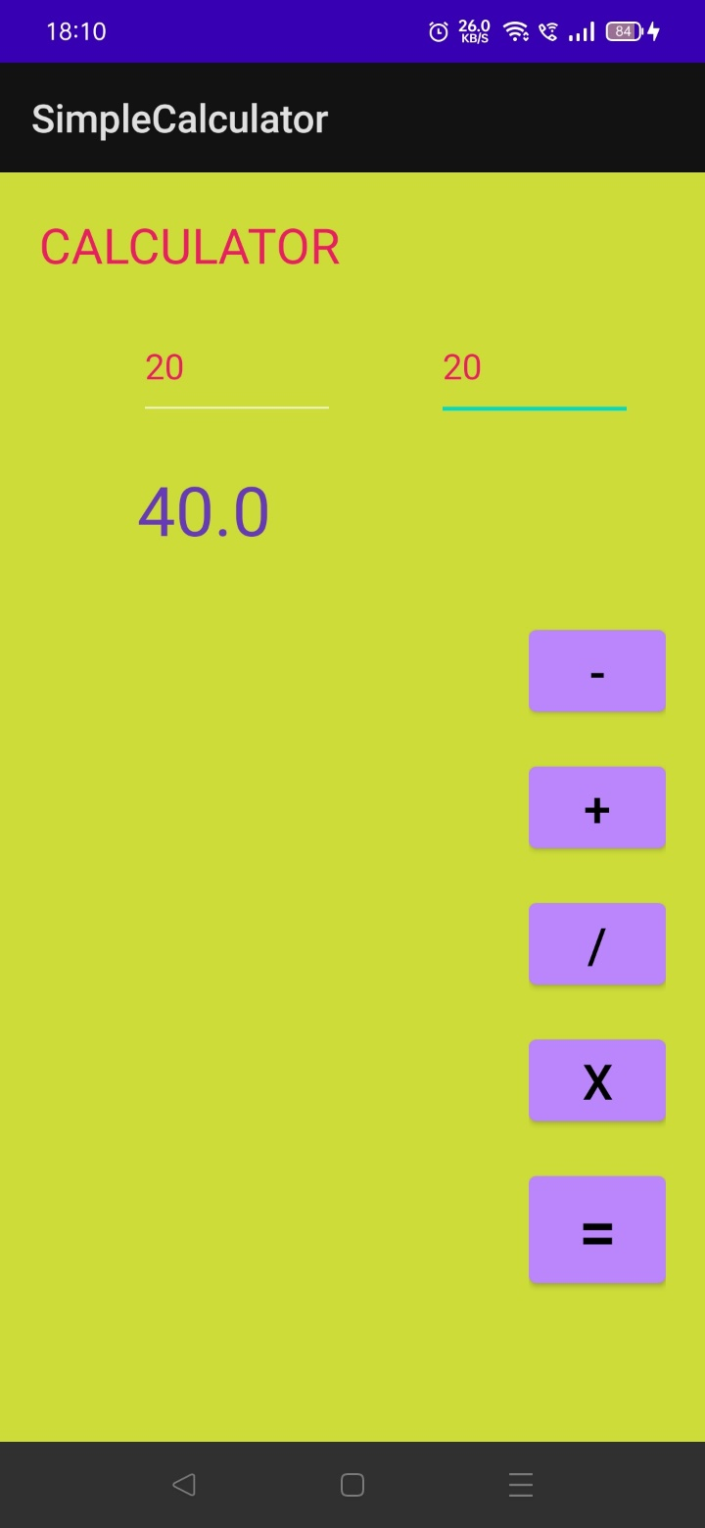

**ADDITION**

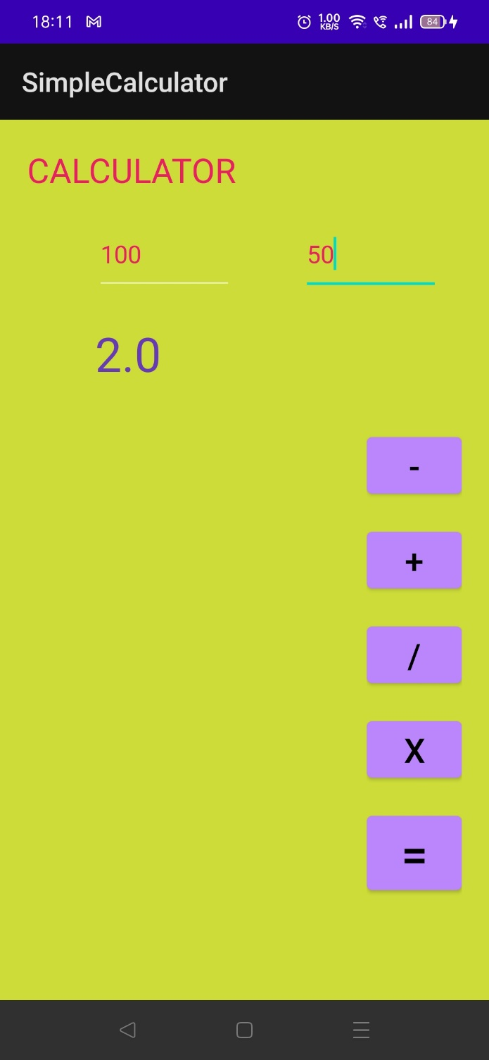

**DIVISION**